Sri Lanka Institute of Information

Technology



Lab Submission

Lab sheet No 07

**IT24101843**

**Dharmadasa K.A.Y.T.H**

**Probability and Statistics - IT2120**

B.Sc. (Hons) in Information Technology

Part 2

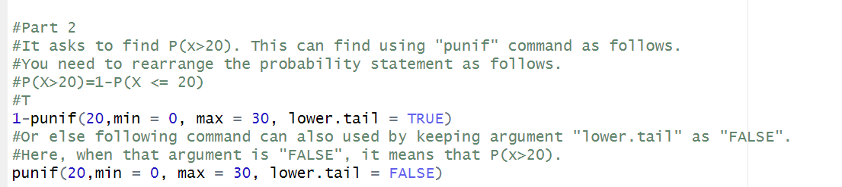

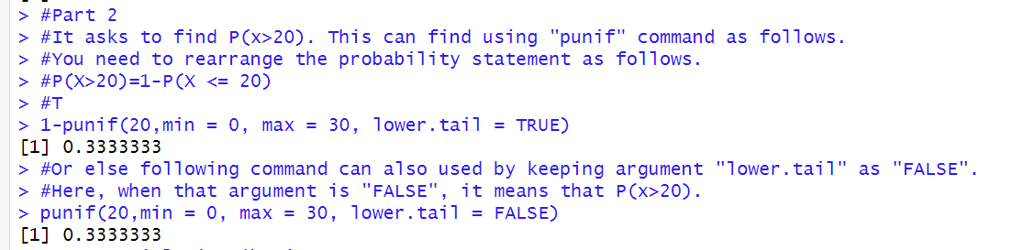

Question 2

Part 1, 2

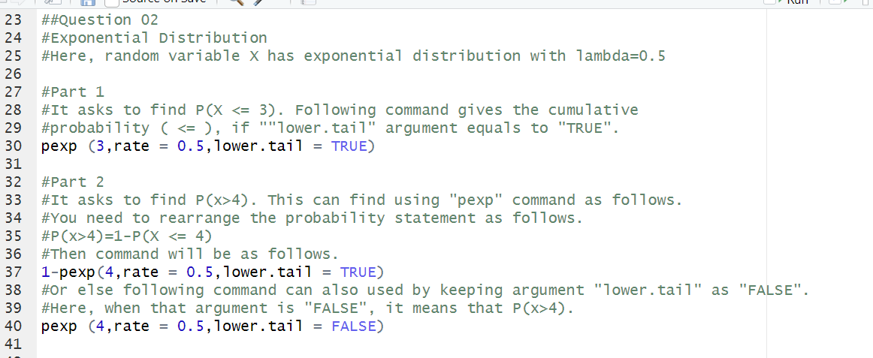

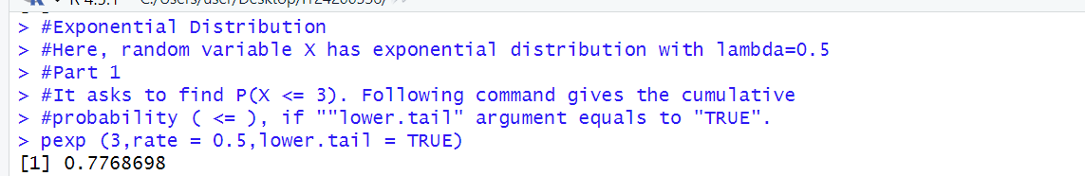

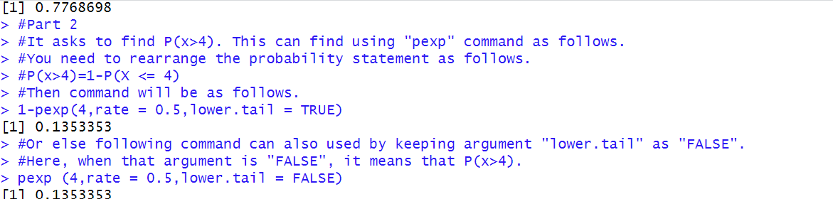

Part 3

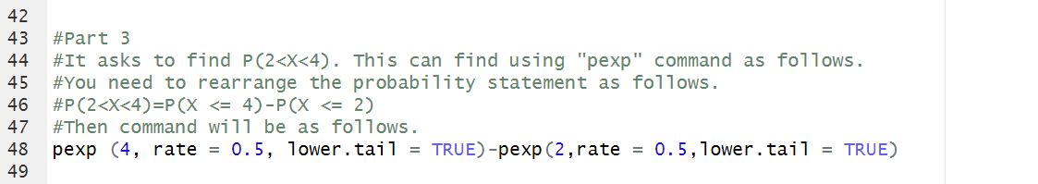

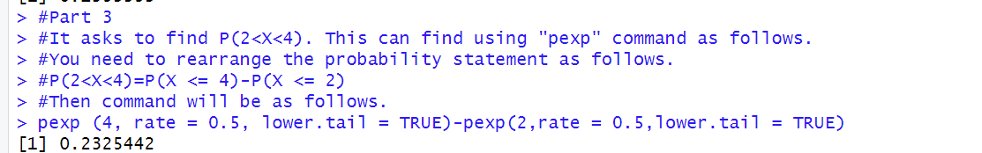

Question 3

Part 1

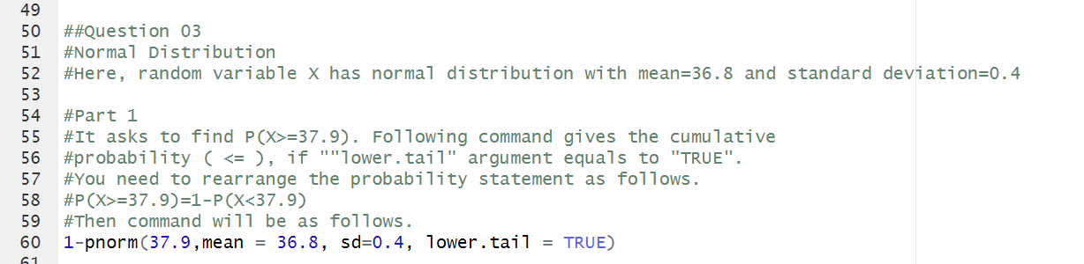

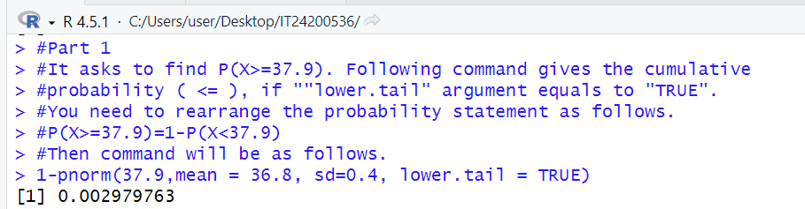

Part 2

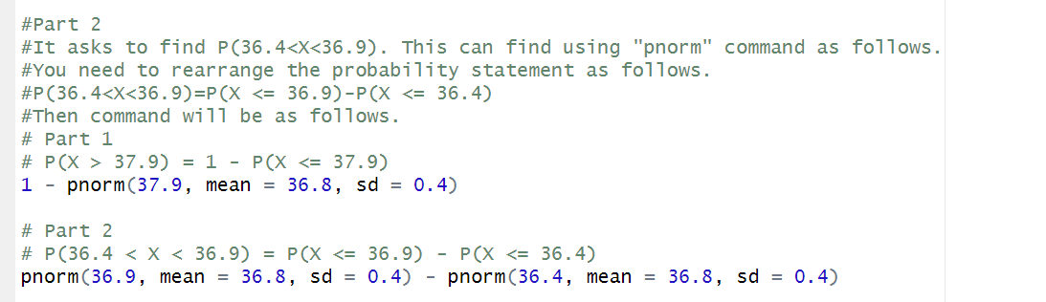

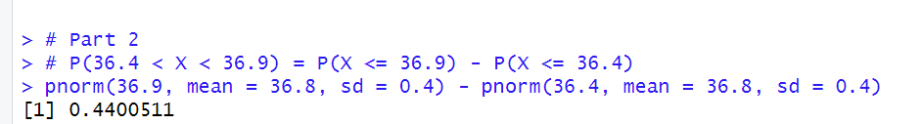

Part 3

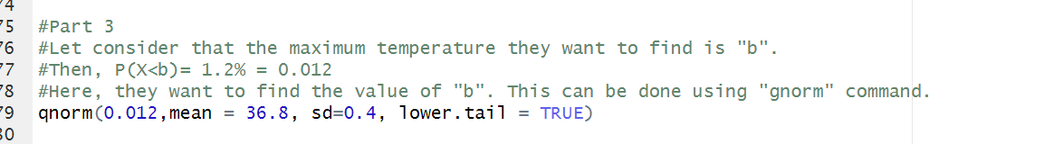

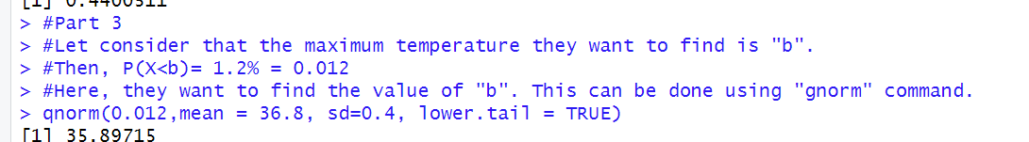

Part 4

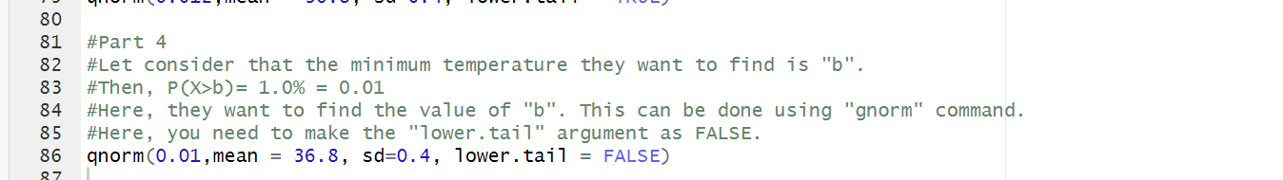

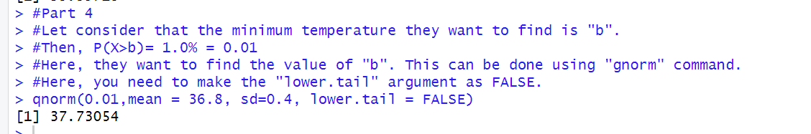

Exercise

Question 1

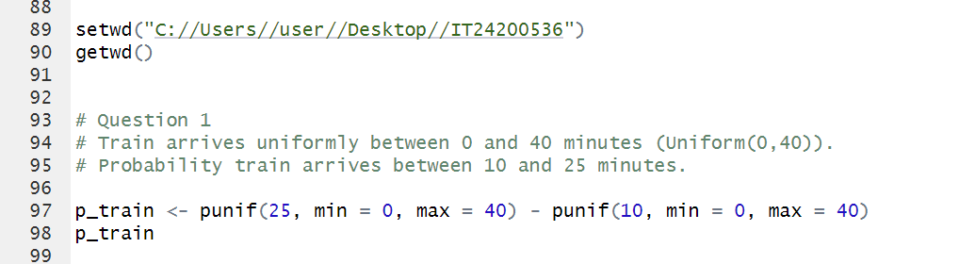

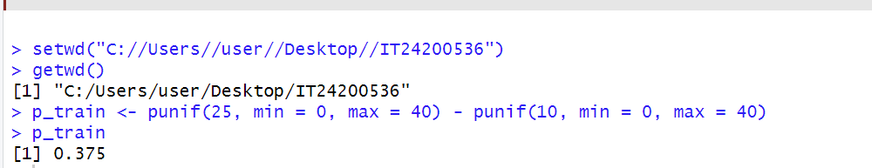

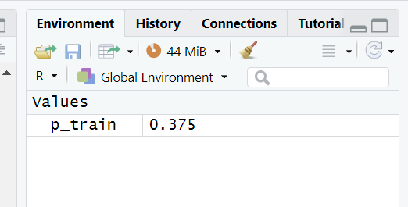

Question 2

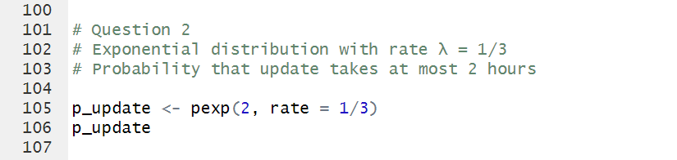

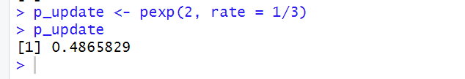

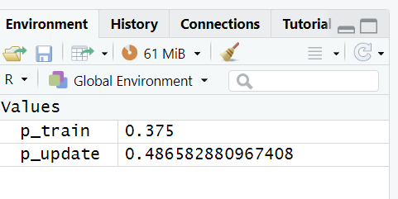

Question 3

